* RestClient
* Different HTTP Methods (GET/POST/PUT/DELETE)
* POSTMAN
* URL and URI
* Header
* Response
* Swagger Documentation

How do you call REST API’s?

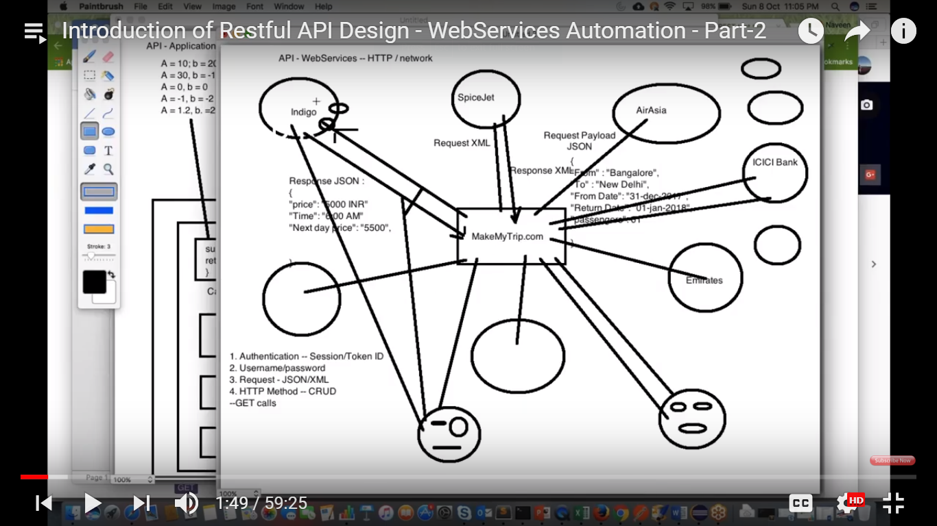

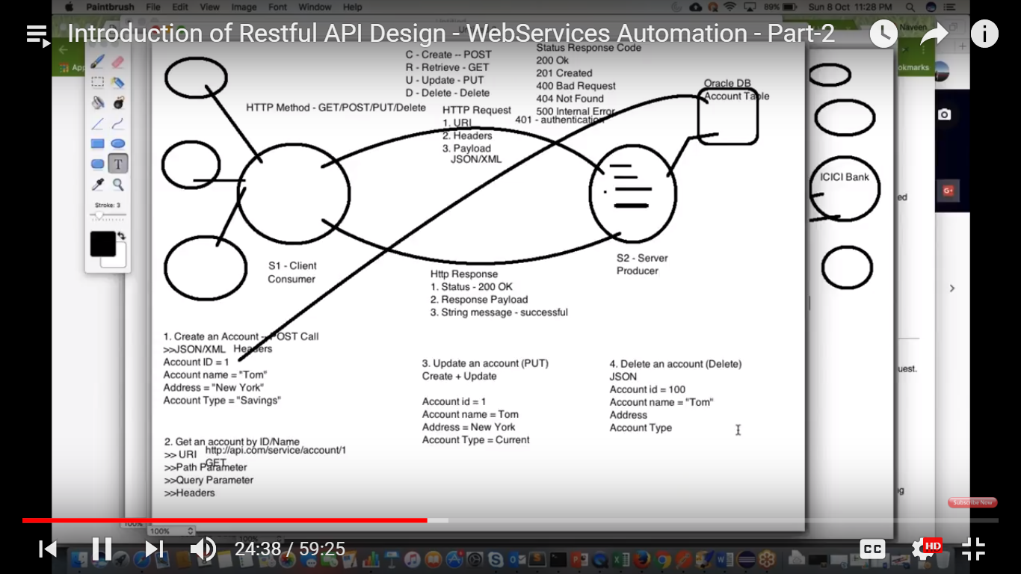

There are 2 systems.

S1 and S2 .

S2 is machine / VM/Cloud server which is hosted anywhere in the world and available in the network.

S2 has API’s . It has weather data / or account system is there where you can create particular account There is bank account- You can create , update , delete , retrieve the bank account information .

CRUD

* Create - POST
* Retrieve - GET
* Update - PUT
* Delete - DELETE

S1 – Client machine / CONSUMER – This will consume the data

S2 – Server/Producer who produces the date and gives the data

This client is having different audience ,for US audience , they have US data

For India , they have India data

These audience will interact with S1 client (Make My trip) and get the data.

MakeMyTrip will fetch the data from S2 server and it will give it audience.

S1 needs the data . So , S1 will call S2 system API’s and send a request.S2 will send a response

S1 sends HTTP request to S2.

When sending HTTP request we pass 3 things POST

* > What is URI
* -> what are your different Headers
* ->what are your Payloads (- JSON/XML if any POST / PUT calls ) are there

These things we pass to S2 server.

S2 will read the request. This payload will be anything. It can be JSON/XML payload .

S1 sends request that I need account information about Ananth .

S2 – ICICI bank system . ICICI bank system will give the account system information in the form of response

HTTP response

* Status – 200 ok
* Response payload
* String message – successful or Not

These Request / Response is applicable for CRUD operations.

What is POST , PUT , GET , DELETE

POST Call is used to create new entity.

I want to create an account- Fresh account – POST Call

* We pass JSON/XML file with below info:

ACCOUNT ID = 1

ACCOUNT NAME = TOM

Address = NY

Account Type = Savings

In S2 sever , some database is available (Oracle) – We have account table.

This account entry will be created in the database . One account will be created in database.

S2 server is connected to database. S2 will fetch the data from database and give to s1

Retrive – Fetch – Get - By id /Name

In Get call , we don’t pass any payloads (JSON/XML)

* > URI
* -> Path parameter
* -> Query parameter
* -> Headers

Account id = 1 , I have already created , what will be my URI?

<http://api.com/service/acount/1>

<http://api.com/> is the s2 sever host name

In S2 server , one service folder is available ,

In this service folder , go to account class

From this account class – class this method and get account id 1 .

URI – combination of path parameter and query parameter

Suppose I give account id is 100 , but that apccount is not there , so you will get Not available – Error 404.

If available – You will get response code 200.

UPDATE - PUT CALL

Using put , if you want to create an account 200 , you will be able to create it.

PUT – Combination of create and update-

PUT – Create – update

Account id = 1

Account name = Tom

Address = NY

New Account Type = Current

Account Type will be updated from Savings to current.

Once updated , I will check with GET call if the account is updated or not.

The response will give me new account type , rest of the account details will remain same.

PUT - Create and as well as update the existing entity.

DELETE – DELETE CALL

Will pass JSON payload

Account id = 1

Account name = Tom

Address = NY

Account Type = Current

This will be deleted from API.

With each and every request, we get response code, we need to understand the response code.

Status Response code

200 – Success

201 – using post call , we have created successfully (when using POST call)

400 – url is wrong , payload is wrong some attribute is missing in pay load – bad request

401 – authentication error.

404 – when account id is not there , and you want to delete that account – 404 not found .

You are trying to access which is not there in the server .

500 – bank server is down . server internal error.

Status code : https status code wiki



How will you access API ?

* > Through UI /APPLICATION, I can hit API
* -> In some system , you don’t have any UI , you just have back end

To test these API ‘s we need one client - >REST API CLIENT .

POSTMAN is REST client

SOAP UI - REST CLIENT and SOAP client

Advanced Rest Client

JMeter – you can hit API’s.

Browser – we can call API

Suppose if you want do POST ,PUT ,DELETE , RETRIEVE – POSTMAN is the

Most famous tool

REST – Representational state transfer.

POSTMAN

* Open google chrome
* Download postman

<https://www.getpostman.com/apps> - you can download from chrome web store

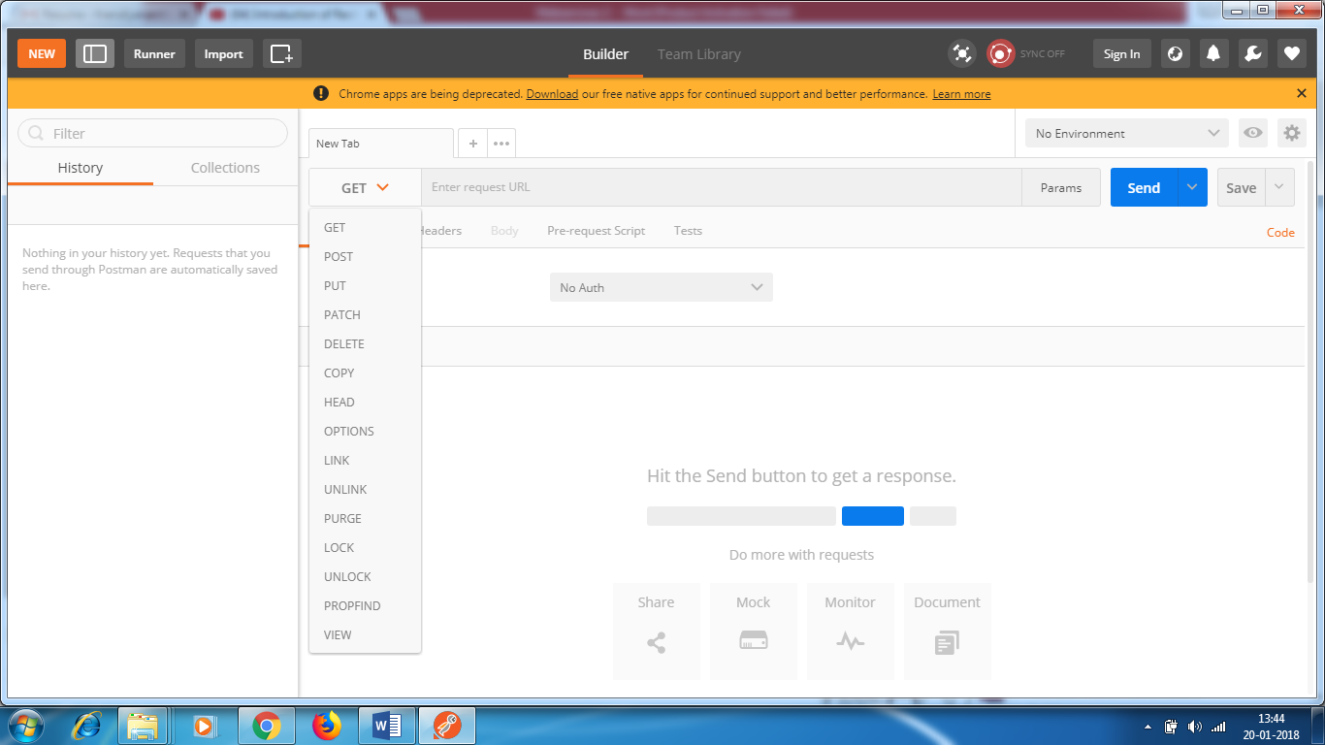

We use only GET , PUT ,POST and DELETE

https://reqres.in/ which gives proper POST , GET , Put etc calls ,There is no such API portal so that I can hit my API’s.

Nobody will allow you to create so many entities with the help of POST call.

This is the dummy API portal

<https://reqres.in/> - end point url + API/Service Url = URI.

In any API testing, we need to ask developers to give end point URL

Example1 : GET QUERY PARAMETER

Generally

Request : URI , Headers , PayLoad

Response : Status , Response Payload ,String message

But for GET

Request - Only we pass URI , query parameter . We don’t pass PayLoad

Response – We get response code , JSON object

ist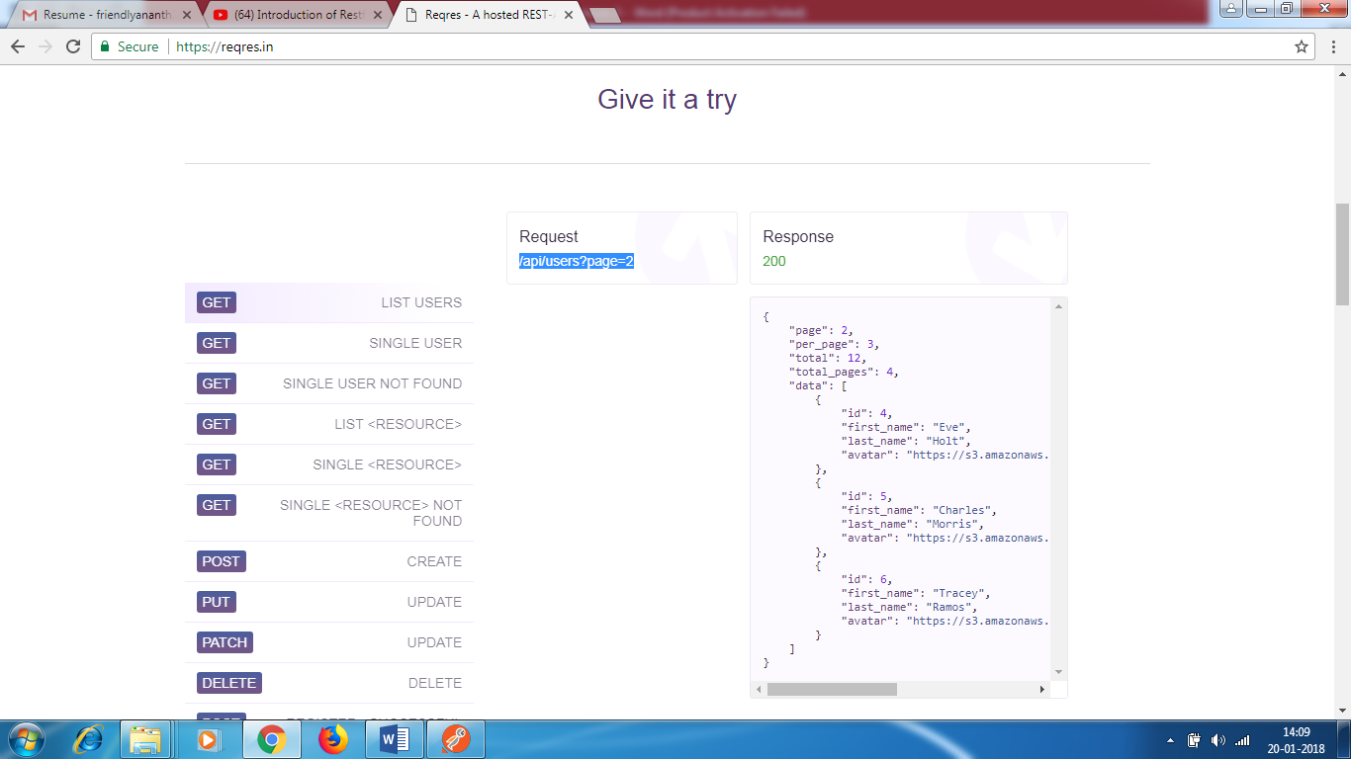

* Click on Get , you will get list of users.
* Also , you will get API URL -   
  /api/users?page=2
* Now , you enter <https://reqres.in/api/users?page=2> , you will get the response
* If you don’t enter ? ,it will list all the users. If you have 100 users , it will give 100 users
* ? is used to filter the results
* If you want users having first name = ANANTH , then you get only those results , this is called query parameter.
* <https://reqres.in/api/users?page=2> - ? is called query parameter , page 2 is parameter , 2 is value
* It depends on how developers have created query parameter in their code

Put this query parameter in POSMASTER ,

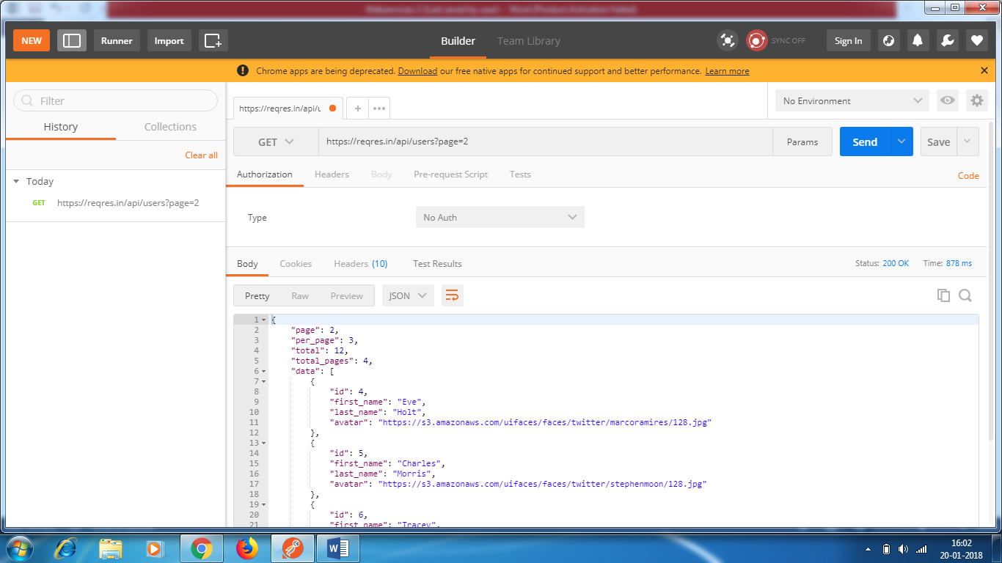

GET

Request - Only we pass URI , query parameter . We don’t pass PayLoad

Response – We get response code , JSON object

If we give invalid URL in POSTMAN , we should get 400 error . but tethis is a dummy site so we don’t

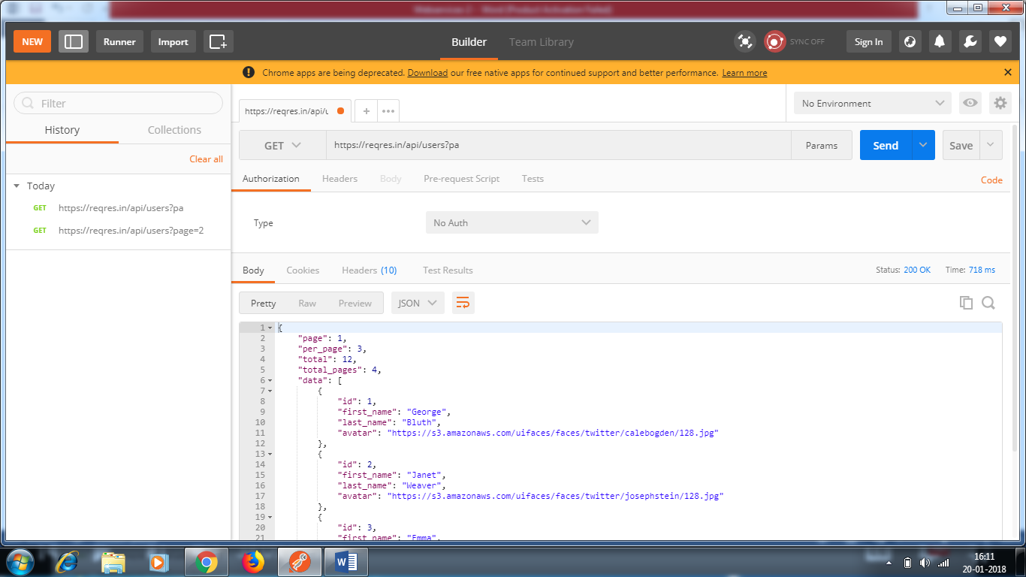

EXAMPLE 2 : GET PATH PARAMETER

If you want to fetch for specific data , for specific user , Single user

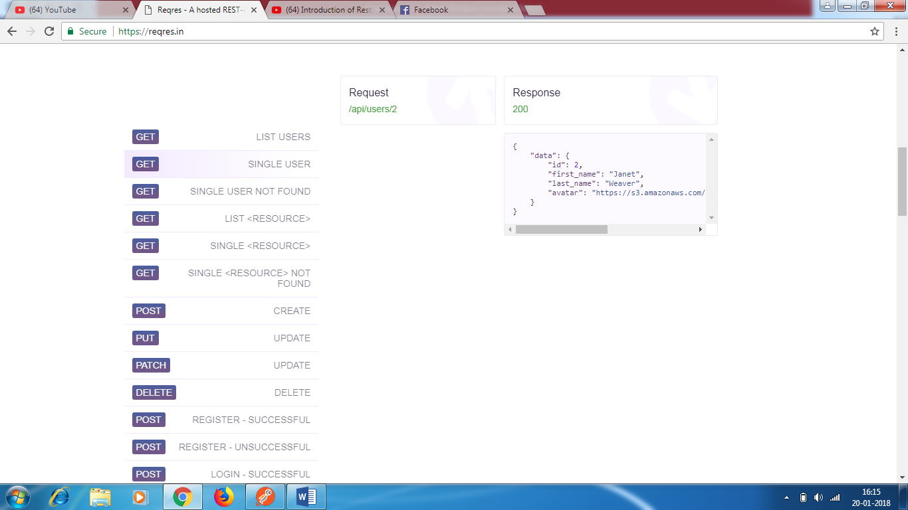R

In the POSTMASTER , enter <https://reqres.in/api/users/2> in request and you get the response for single user.

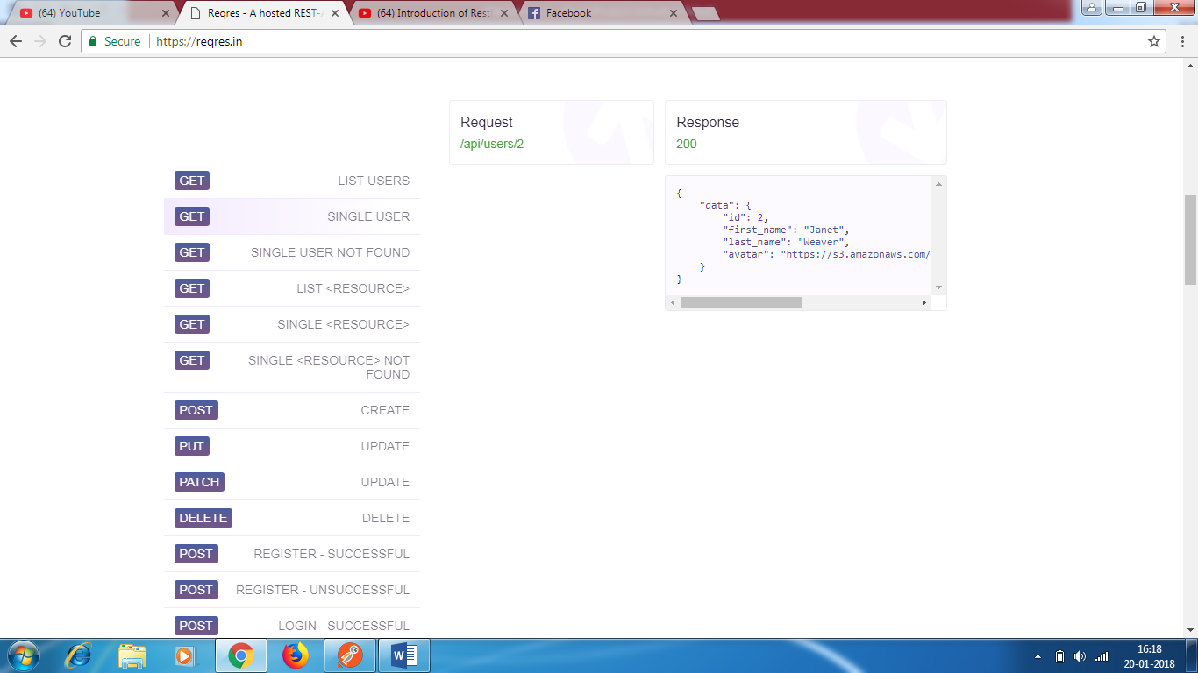

<https://reqres.in/api/users/2> - This is called path parameter.

Path parameter - \

QueryParameter - ?

Query parameter – filter your records

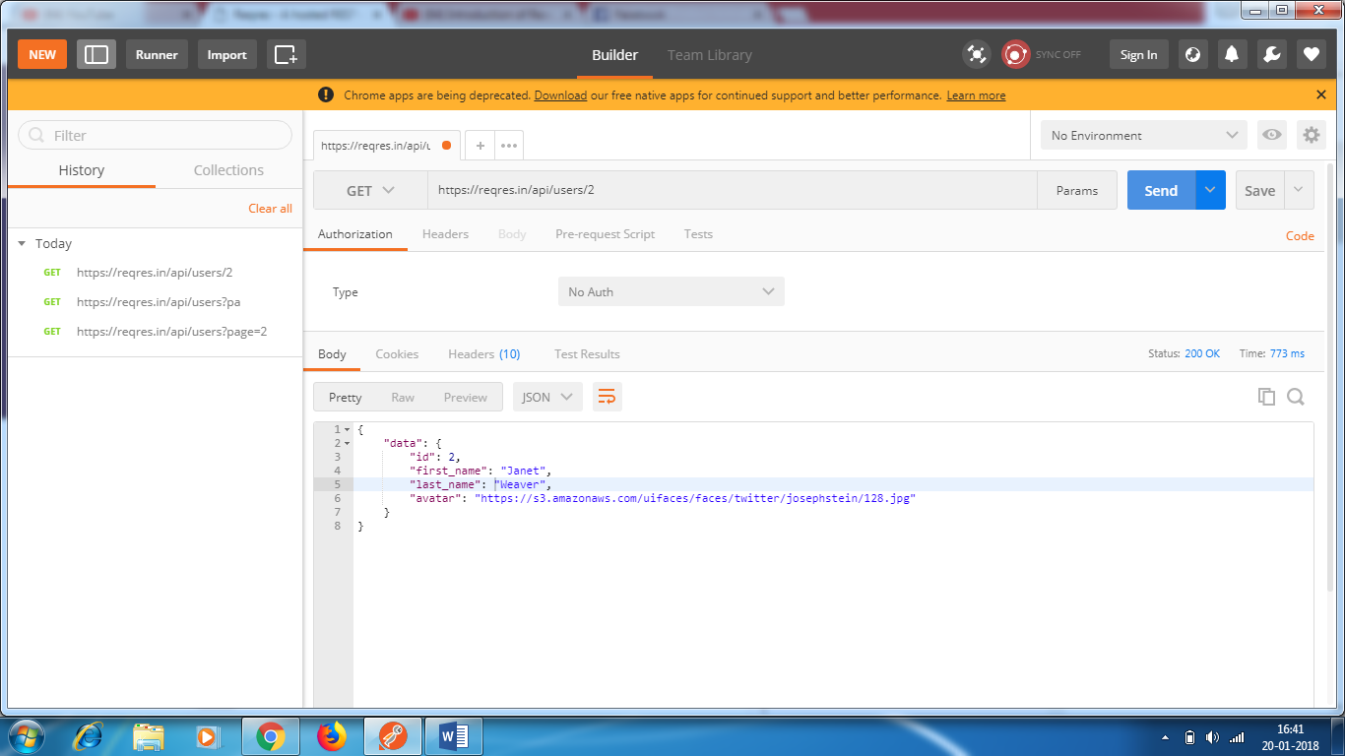

[https://reqres.in/api/users/100 - 404](https://reqres.in/api/users/100%20-%20404) ERROR

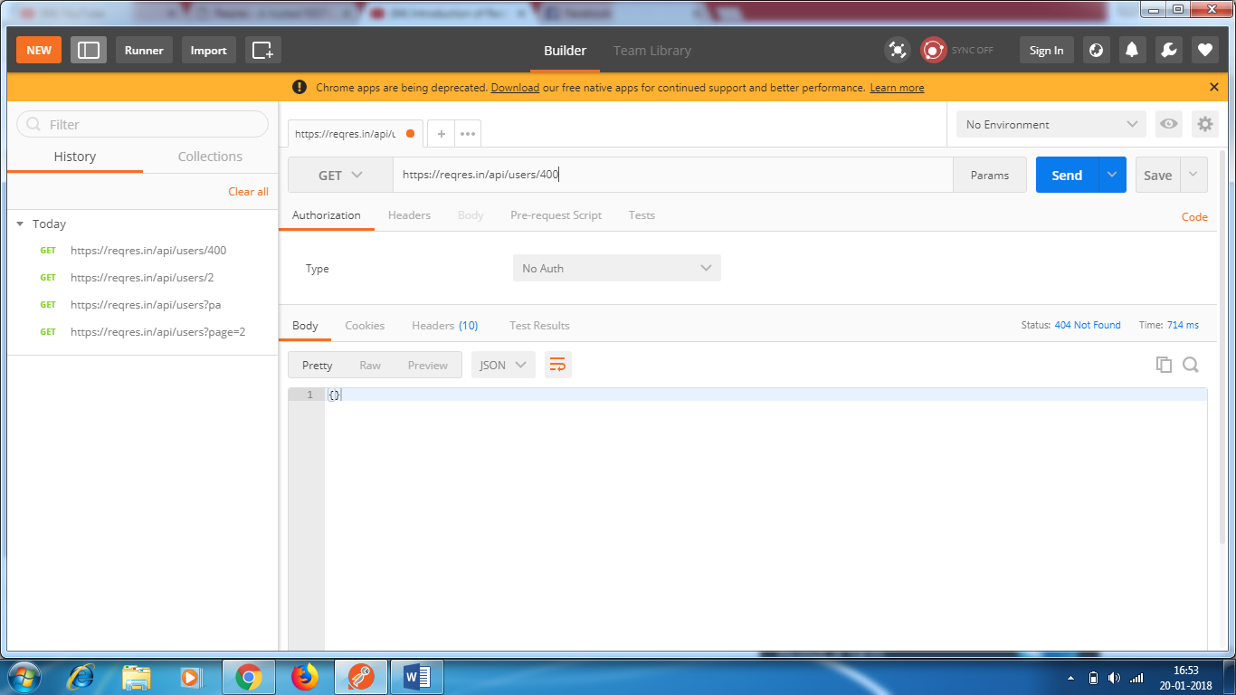

POST CALL

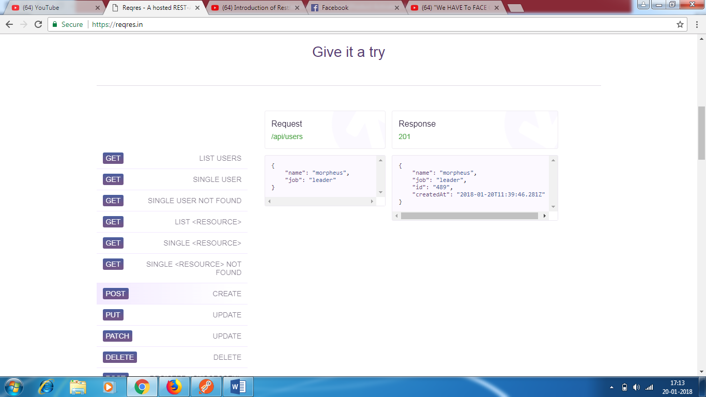

Select POST in POSTMASTER, give the URI <https://reqres.in/api/users>

Select Body

Select Raw

Select JSON

Paste the request

{

"name": "Ananth",

"job": "Testing"

}

Request

Header

URI

PayLoad

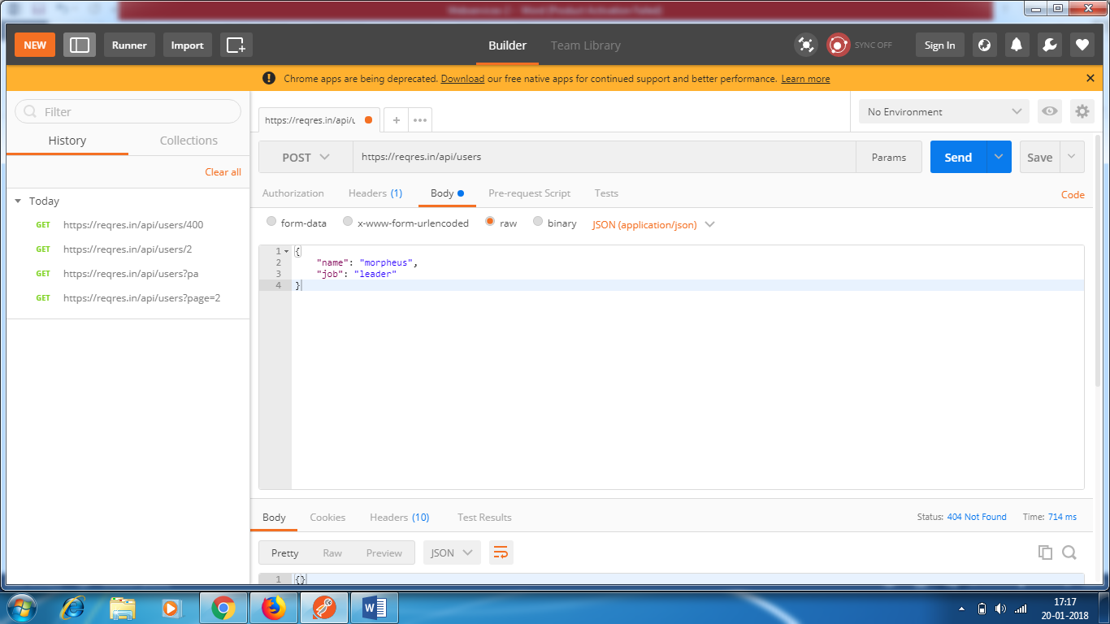

Response:

It gives JSON file – name ,job , id , create date

Response code – 201

Status message : created

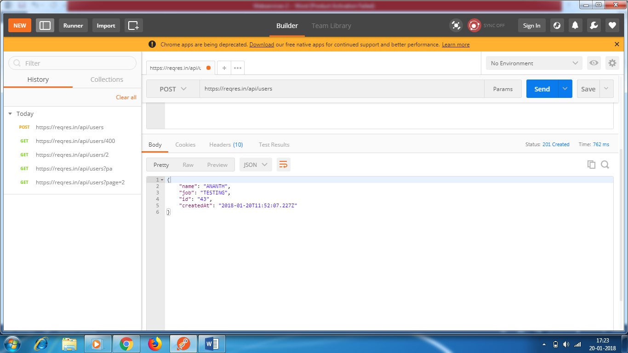

Creating another record

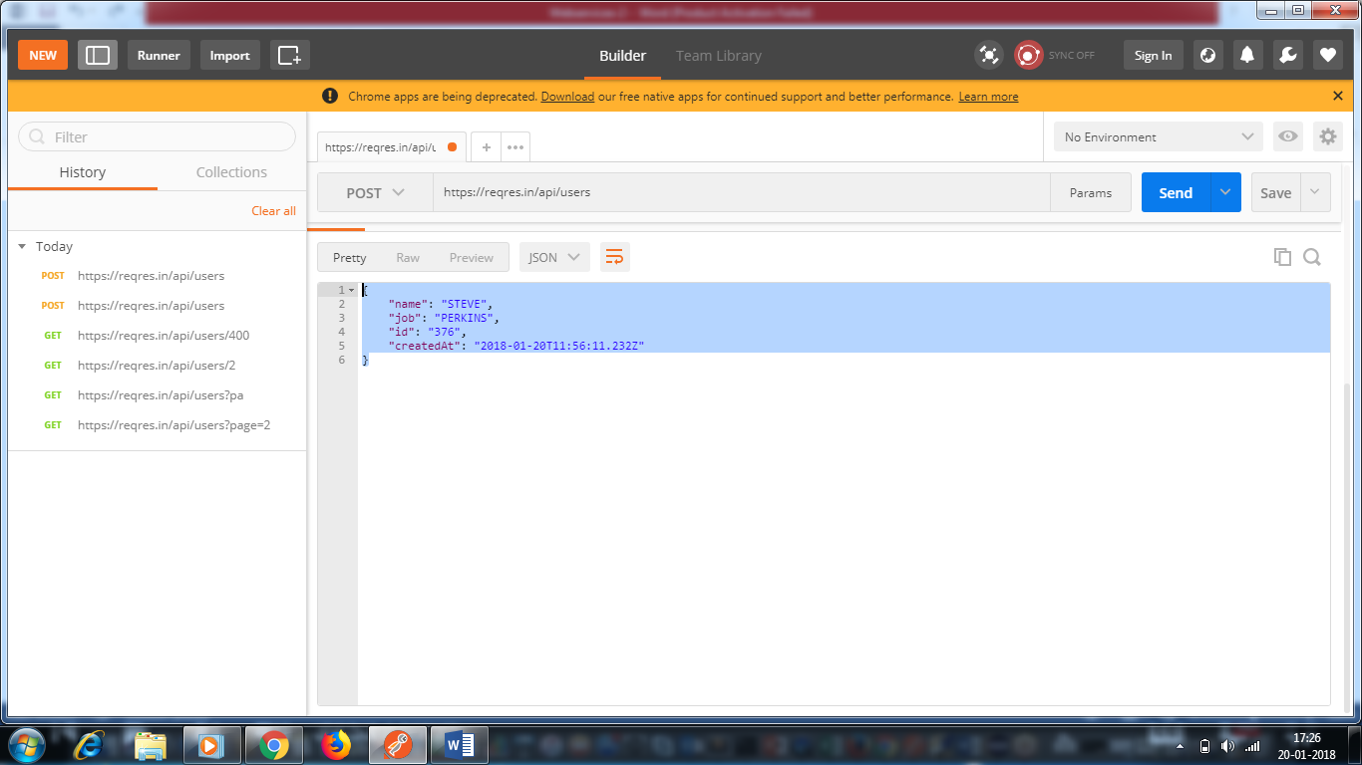

PUT CALL

Request

Header

URI

PayLoad

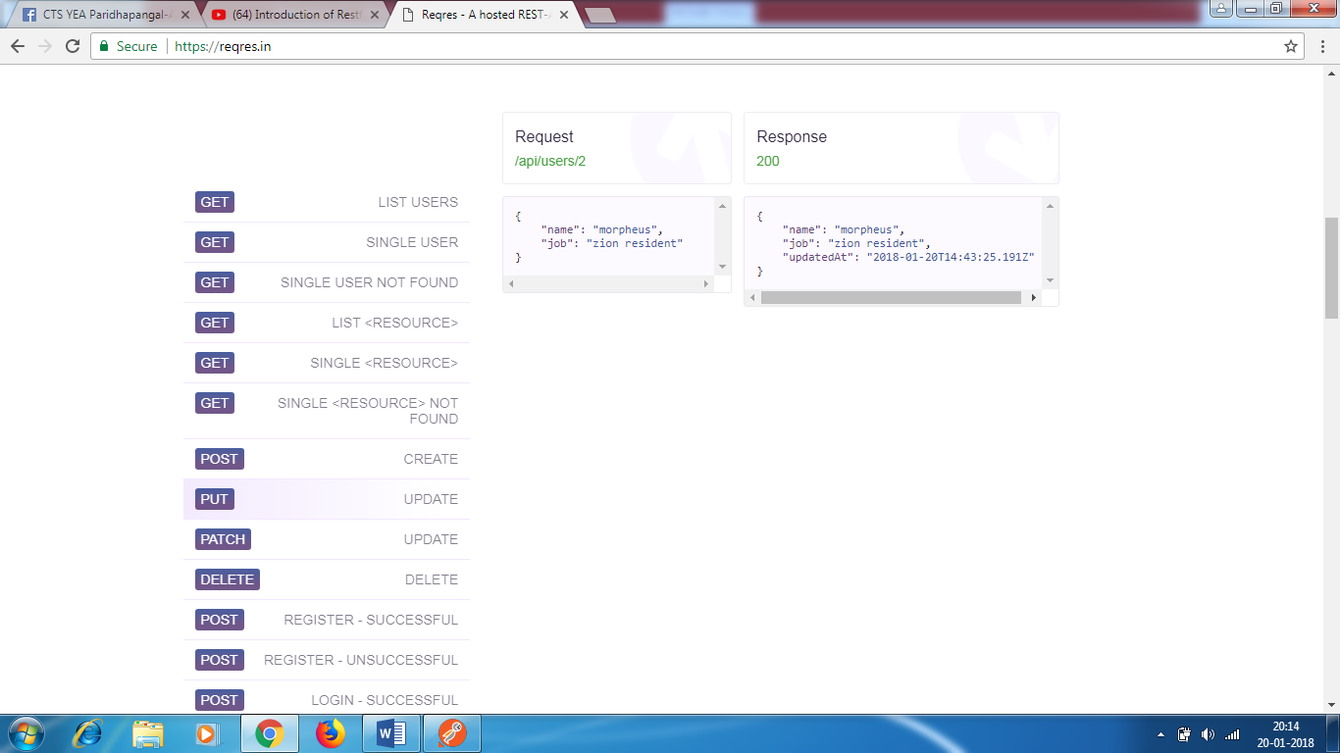

* Select PUT in POSTMASTER
* Enter the URI <https://reqres.in/api/users/2>
* Select Body
* Select Raw
* Select JSON
* Paste the request

{

"name": "morpheus",

"job": "Manager"

}

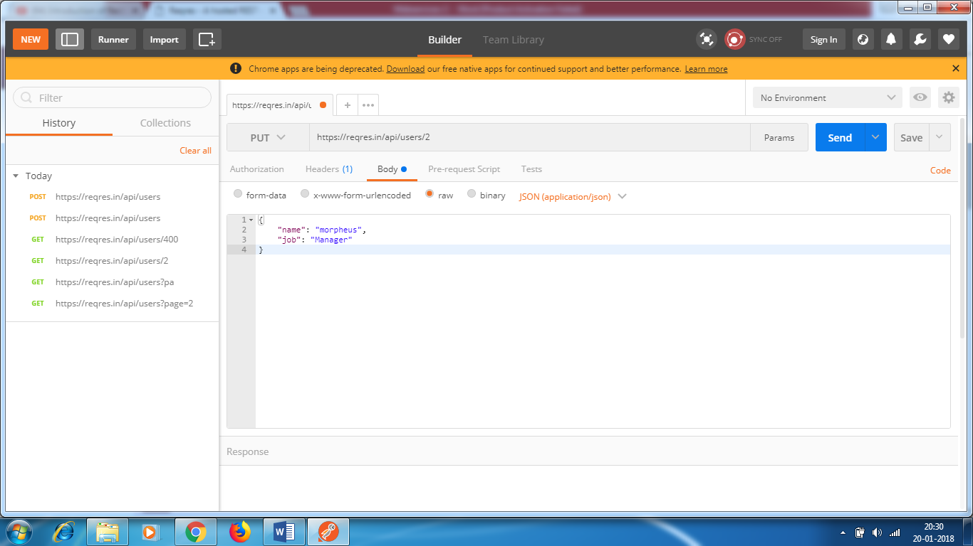

Click send button

It will give the response

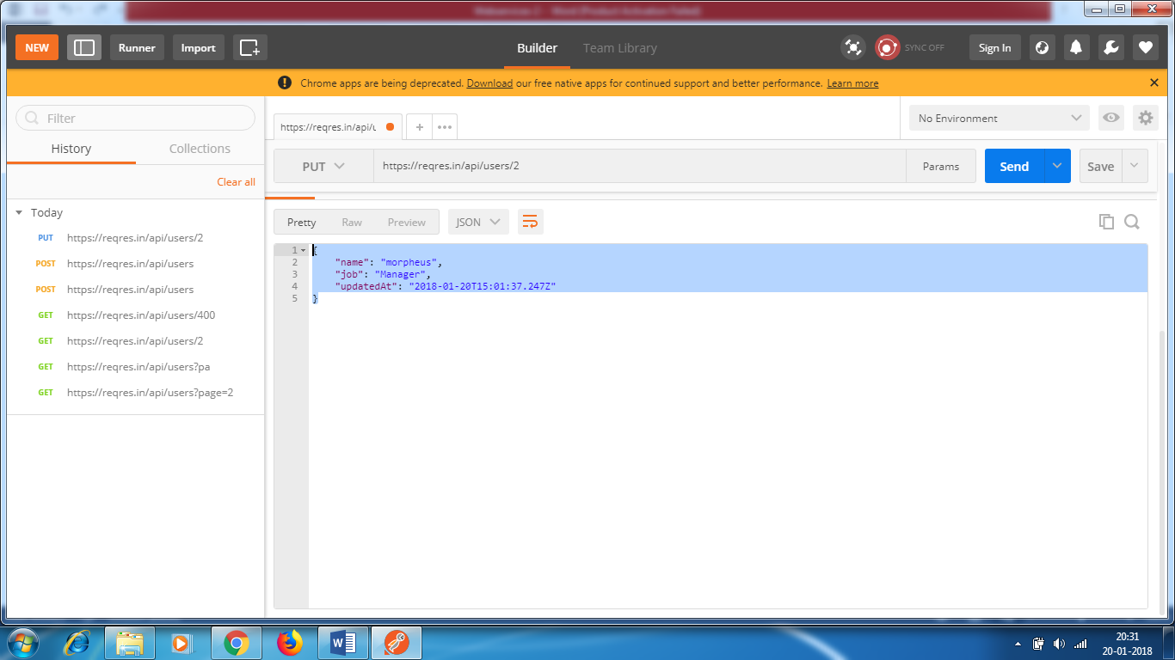

It gives JSON file – name ,job , id , UpdatedAt

Response code – 200

Delete Call

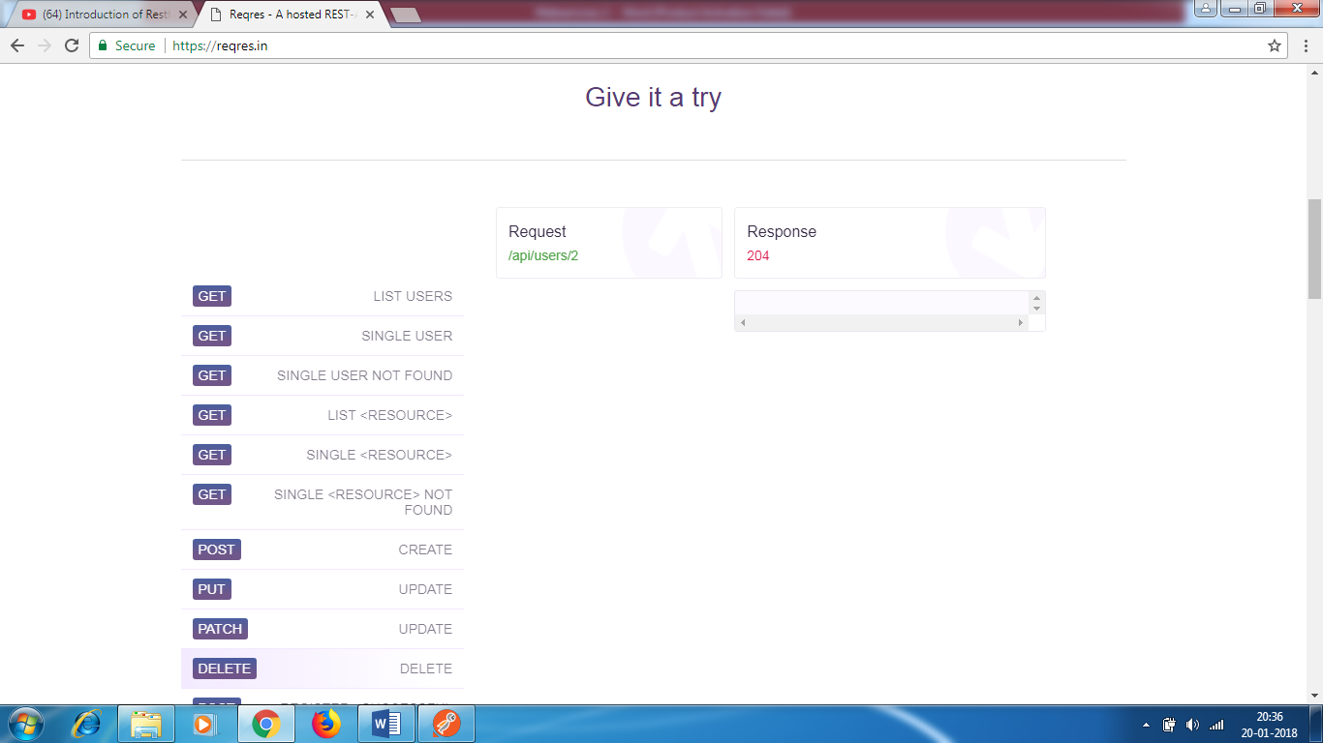

* Select Delete in POSTMASTER
* Enter the URI <https://reqres.in/api/users/2>
* No PayLoad is required

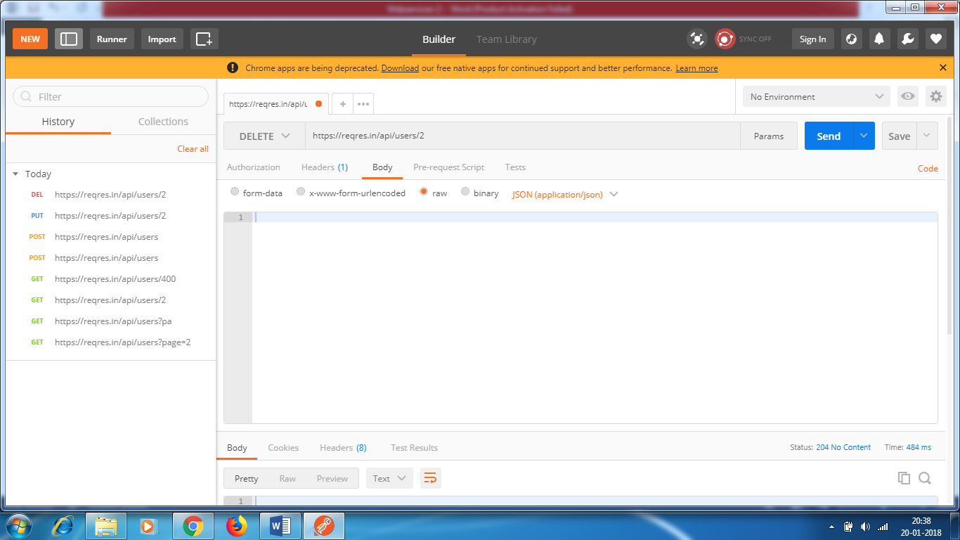

Click Send button

* You will get a response saying content is deleted. No Content
* Status : 204 – means it got deleted.

SWAGGER – API documentation tool

* Like we have java documentation , similarly we have api documentation.
* It will tell you what are the different API’s available on your server.

These many API’s are there in activities.

* 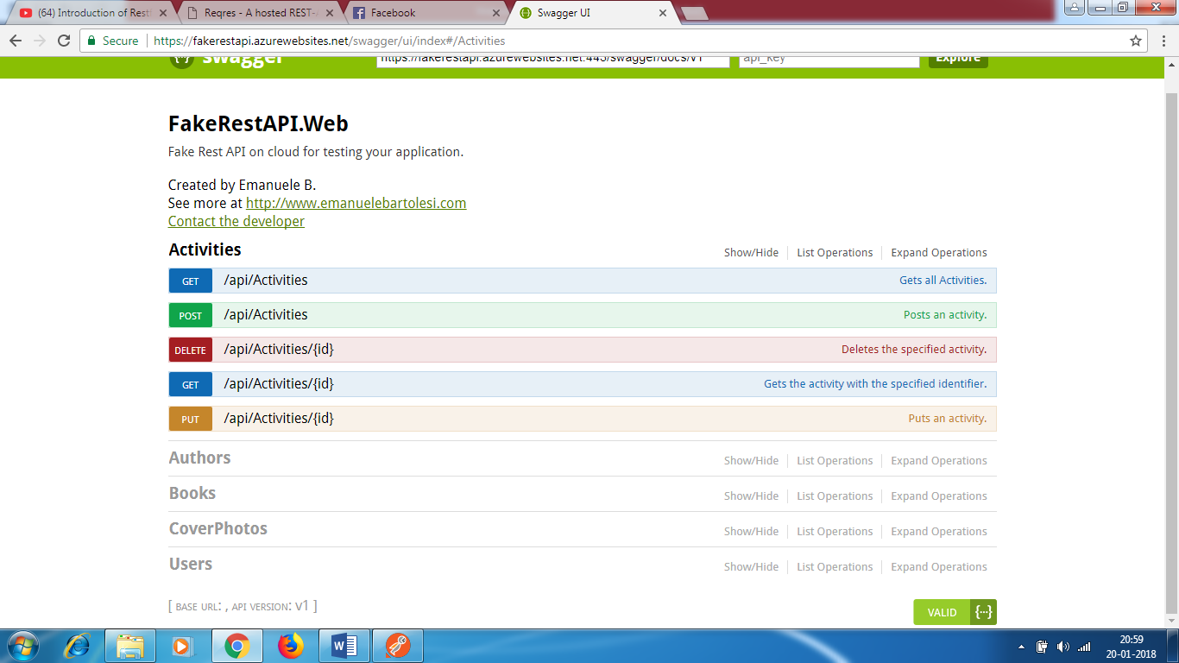

* In Swagger , you can hit the API directly. No need to use POSTMAN

Click on GET and try it out

* GET will show you number of activities. – 30 activities.

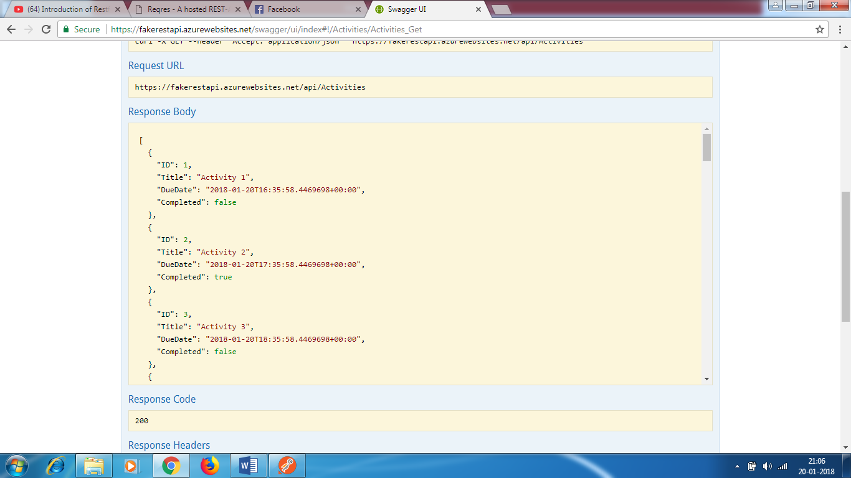

* > In Response also , we get headers.

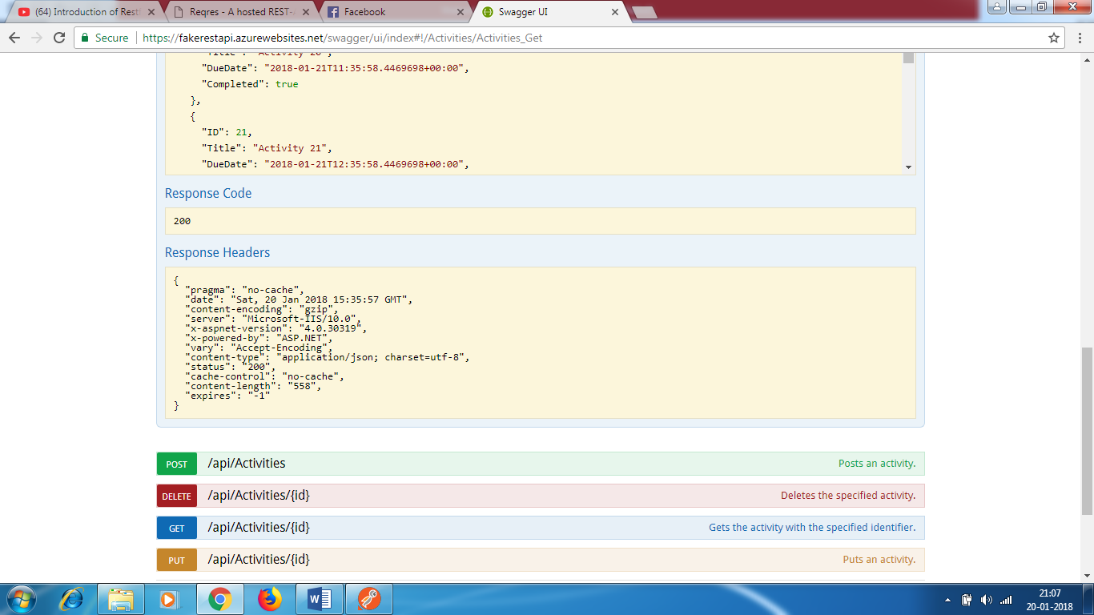

* If we enter the URI in POSTMAN , we can hit the API. The same results will be shown.
* URI - <https://fakerestapi.azurewebsites.net/api/Activities>

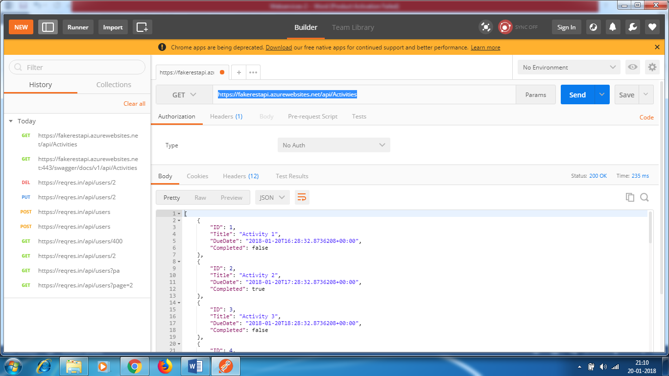

GET - Suppose , if I want to fetch for specific id

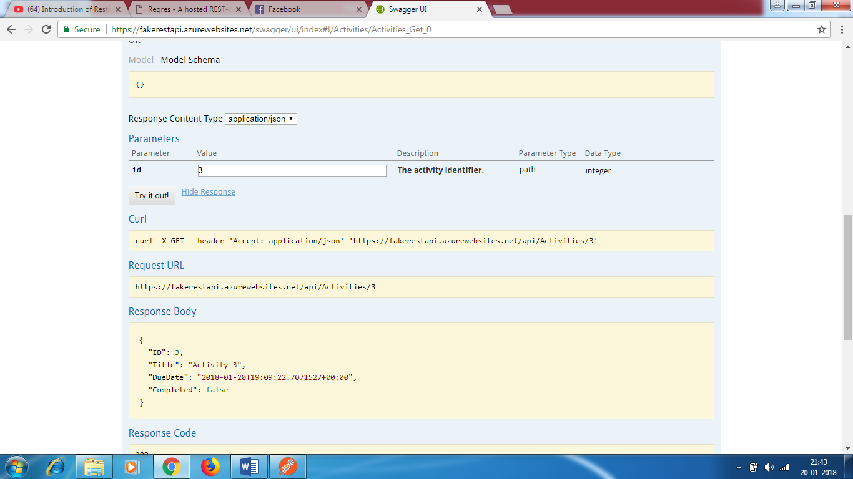

URI - https://fakerestapi.azurewebsites.net/api/Activities/3

POST

* You need to send pay load
* URI
* Headers

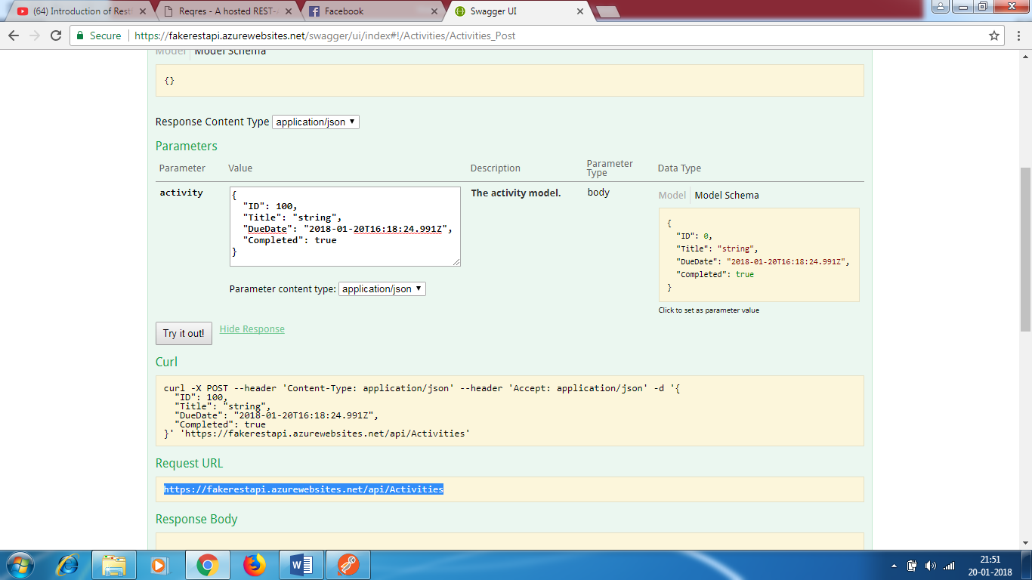

Response – ID is created

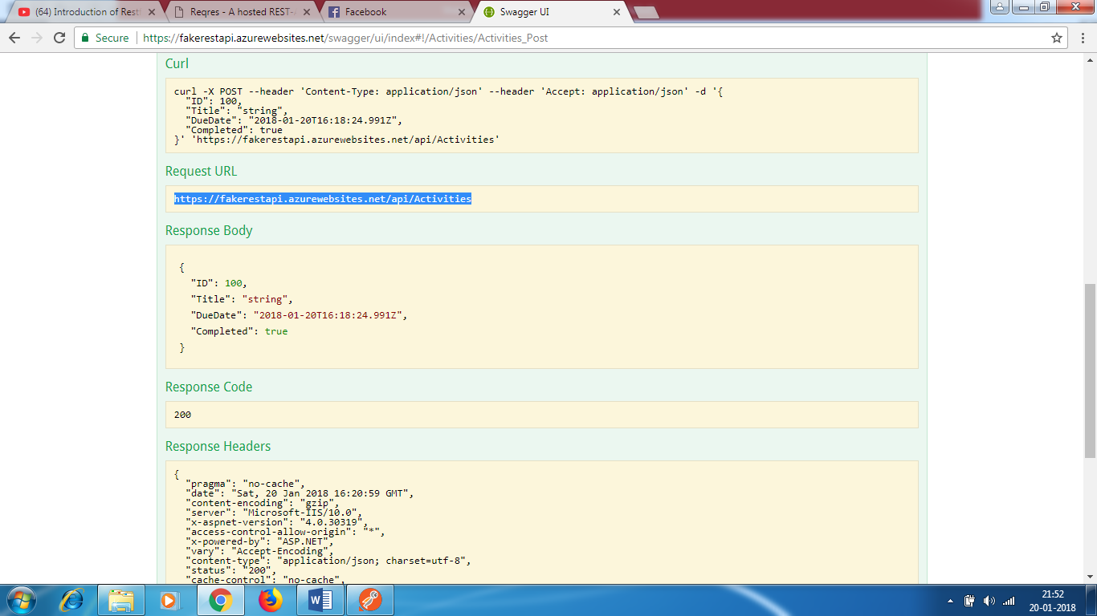

Developer creates swagger. Its a server and they have to implement in their code . They use swagger API and

Swagger annotations

Swagger – Hit the API and test the API.

I can ask the developers to call the API , fetch the information and display UI.

